Project 1
<Numbers game>

CIS-5 49006
Name: Arturo Aguilar
Date: 11/4/17
Introduction
Title: Numbers Game
This is a game to guess a number betwenn1 and 999.
The computer will randomly select a number between one and nine hundred and ninety-nine. The user has 10 tries to guess the correct number. To add a challenge, the number enter by the user will converted to roman numerals.
Example: if the user enters the number 357, the game will display CCLVII.
When the user fails to guess the correct number in ten tries, the game is over.
If the number is guess in less than ten tries the user wins.

This game utilizes the user’s logic and it helps to recognize roman numerals.

Summary
Project size: about 160 lines.
Number of variables: about 68
Number of method: 5

This project includes many concepts that we learned for the chapters in the book.
It has the possibility to be extended for the next project.
Like adding a time limit to the user’s guess.

It took more time than it was estimated. At first, it was a simple guess game and it was very small. I needed to add more code and make it a little more challenge. I encounter to many toubles when I tried to implement the roman numerals. I am not completely happy with the project, but there is not enough time to get the project to its best potential.
I realize the sequence in which the code is written leads to the program running properly.
The new concepts that I had to construct from the chapter we have cover is the bools and loops and flies, making decisions and functions.

Description

The point of this program is that how the roman numerals are integrated during the guessing game.
Pseudo Code

The program is started
Display the name of the game and asks the user to begin to guess the number
User inputs its first guess
Switch is initialize to convert to Roma numerals
Case to identify the correct number for the hundreds from one to nine
Case to identify the correct number for the tenths from one to nine
Case to identify the correct number for ones from one to nine
If the number the user guessed is greater than the random number
Display “too high”
If the number the user guessed is lower than the random number
Display “too low”
If the number the user guessed is not equal to the random number
Displays how many tires the user has left
If the number the user guessed is equal to the random number
Congratulates the user for winning the game
If the user exceeds the amount of tries
The game is over, the user is encouraged to try again
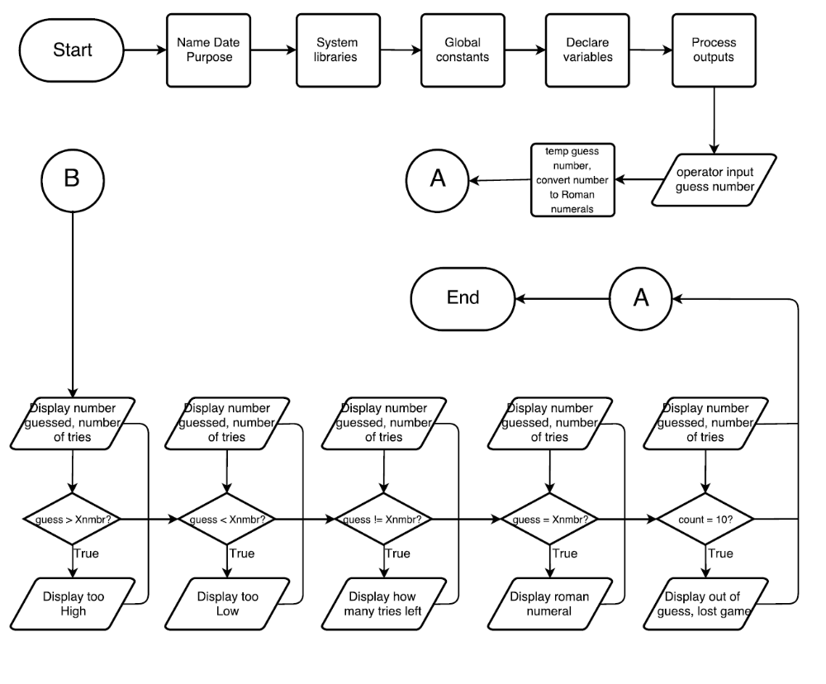
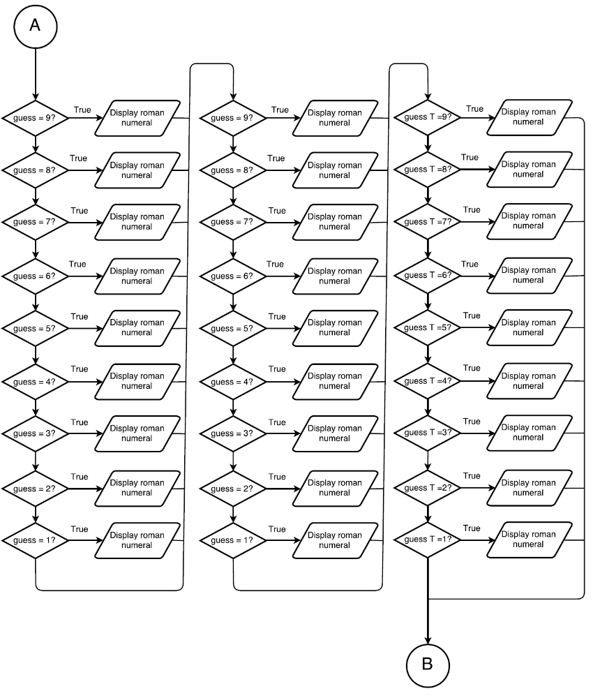

Major Variables
Type | Variable | Description | Location
Constant Integer | THSNDS | Number to recognize one thousand | Global Constant
 | HNDRDS | Number to recognize the hundreds number | Global constant
 | TENS | Number to recognize the tenths numbers | Global Constant
 | ONES | Number to recognize ones in numbers | Global Constant
Srand | Random Number | Generates a different number every time the program is run | Declare variables
Integer | Xnmbr | Number randomly generated between I and 999 | Declare variables
 | Guess | Number the user inputs every guess | Declare variables
 | Count | Number the program (zero)generates and adds one every time the user inputs guess | Declare variables
 | numTemp | Temporally number to keep Xnmbr as a single solid number | Map out outputs
 | Temp | Temporally number to keep guess as a single solid number | Map out outputs
Unsigned char | Nthsnds | Number to recognize the hundreds in a number | Map out outputs
 | NTens | Number to recognize tenths in a number | Map out outputs
 | NOnes | Number to recognize ones in a number | Map out outputs
Char | GuessH | Character to identify the hundreds of a number | Display outouts
 | GuessT | Character to identify the tenths of a number | Display outputs
 | GuessO | Character to identify ones of a number | Display outputs

Reference
- Textbook
- Computer Lab
- https://github.com/ml1150258/LehrMark_CSC5_CIS5_Fall2017
- Internet reasearch

Program

using namespace std; //Standard Name-space under which System Libraries reside
//Global Constants - Not variables only Math/Science/Conversion constants
const int THSNDS =1000;
const int HNDRDS = 100;
const int TENS = 10;
const int ONES = 1;

int main(int argc, char** argv) {
//Declare Variables
srand (time(0)); //random number generator
const int Xnmbr=rand() % 1000 + 1; //generates # between 1 and 100
int tries = 0, guess;
int count = 0;
unsigned char NThsnds, NHndrds, NTens, NOnes;

//Process or map the inputs to the outputs
int numTemp = Xnmbr;
NHndrds=numTemp/HNDRDS;
numTemp%=HNDRDS;
NTens=numTemp/TENS;
numTemp%=TENS;
NOnes=Xnmbr;

//Display/Output all pertinent variables
cout<<"Guess my number"<<endl;
while (guess != Xnmbr && count < 10)
{
cout<<"Enter a guess of my number"<<endl;
cin>>guess;
int temp = guess;// convert to Roman;
char guessH, guessT, guessO;
guessH=temp/HNDRDS;
temp%=HNDRDS;
guessT=temp/TENS;
temp%=TENS;
guessO=temp;
switch(guessH){
case 9: cout<<"CM";break;
case 8: cout<<"DCCC";break;
case 7: cout<<"DCC";break;
case 6: cout<<"DC";break;
case 5: cout<<"D";break;
case 4: cout<<"CD";break;
case 3: cout<<"C";
case 2: cout<<"C";
case 1: cout<<"C";
}
//Display The Number of 10's
switch(guessT){
case 9: cout<<"XC";break;
case 8: cout<<"LXXX";break;
case 7: cout<<"LXX";break;
case 6: cout<<"LX";break;
case 5: cout<<"L";break;
case 4: cout<<"XL";break;
case 3: cout<<"X";
case 2: cout<<"X";
case 1: cout<<"X";
}
//Display The Number of 1's
switch(guessO){
case 9: cout<<"IX";break;
case 8: cout<<"VIII";break;
case 7: cout<<"VII";break;
case 6: cout<<"VI";break;
case 5: cout<<"V";break;
case 4: cout<<"IV";break;
case 3: cout<<"I";
case 2: cout<<"I";
case 1: cout<<"I";
}
cout<<endl;
count++;
++tries;
if (guess > Xnmbr){
cout<<"To high!!"<<endl;
}
if (guess < Xnmbr){
cout<<"To low!!"<<endl;
}
if (guess != Xnmbr){
cout<<" nice try, you still got "<<10 - count<<" guesses"<<endl;
}
if (guess == Xnmbr){
cout<<"congratulations, you guess my number in "<<tries<<" tries"<<endl;
}
if (count == 10){
cout<<"you are out of guesses, maybe next time"<<endl;
}
}
switch(NHndrds){
case 9: cout<<"CM";break;
case 8: cout<<"DCCC";break;
case 7: cout<<"DCC";break;
case 6: cout<<"DC";break;
case 5: cout<<"D";break;
case 4: cout<<"CD";break;
case 3: cout<<"C";
case 2: cout<<"C";
case 1: cout<<"C";
}
//Display The Number of 10's
switch(NTens){
case 9: cout<<"XC";break;
case 8: cout<<"LXXX";break;
case 7: cout<<"LXX";break;
case 6: cout<<"LX";break;
case 5: cout<<"L";break;
case 4: cout<<"XL";break;
case 3: cout<<"X";
case 2: cout<<"X";
case 1: cout<<"X";
}
//Display The Number of 1's
switch(NOnes){
case 9: cout<<"IX";break;
case 8: cout<<"VIII";break;
case 7: cout<<"VII";break;
case 6: cout<<"VI";break;
case 5: cout<<"V";break;
case 4: cout<<"IV";break;
case 3: cout<<"I";
case 2: cout<<"I";
case 1: cout<<"I";
}

//Exit the program
return 0;
}

